Challenge | Number of books needed to complete the Challenge | Minimum number of PRC books for your Challenge | Maximum number of personal choice books | PRC booklist selection
K-2 | 30 | 25 | 5 | K-2 , 3-4 , 5-6 , 7-9
3-4 | 20 | 15 | 5 | 3-4 , 5-6 , 7-9
5-6 | 20 | 15 | 5 | 5-6 , 7-9

This year’s challenge has begun again and we would like to encourage all students in K-6 to participate.
The Premier’s reading challenge is a great way for your child to get enthusiastic about reading. The more books they read from the Premier’s Challenge list the closer they get to receive their name on the honour roll for reading. The table above shows you how many books need to be read to complete the challenge. Simply log onto the PRC website to register and record the books as you read them.
Our school library has shelves dedicated to PRC books, so finding them are easy. You can also access the complete booklists online at PRC website. All students entering and successfully completing the Premier's Reading Challenge will receive an official PRC certificate and their names will appear on the PRC Honour Roll. To successfully complete the Challenge students must have an online reading record entered by the end of August.
Alternatively, if you have difficulties completing your reading record online you can complete the attached paper copy and return it to school when completed.
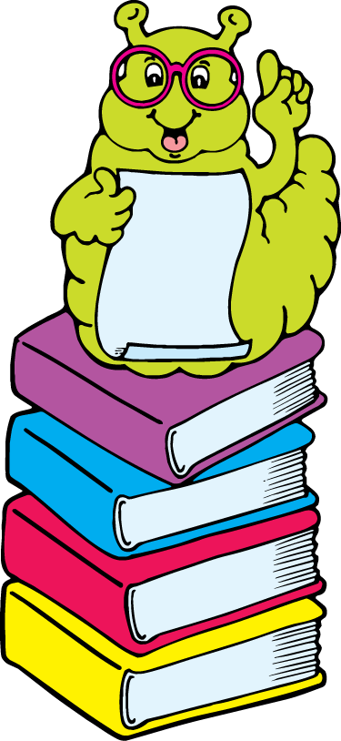
How to complete the PRC online
Visit the Website www.premiersreadingchallenge.nsw.edu.au
On the side bar you will see an icon labelled Logon.
Type in your student username and password
Click on STUDENT READING RECORD
Enter your books

If you have any questions about this year’s PRC, please contact Ms Armstrong or Miss Beker.
Happy reading!

